Experiment 11 – Nmap Timing and Performance Commands

11. Execute and display the results for the following Nmap Timing and Performance commands in Kali Linux Operating Systems:
(i) Aggressive speed scan
(ii) Insane speed scan

Aim: To execute and study the aggressive speed scan and insane speed scan options of Nmap in Kali Linux and observe their outputs.
1. Aggressive Speed Scan
Command
nmap -T4 10.0.2.15
Explanation:
The nmap command is used to scan a host and identify open ports.
- -T4 specifies the Aggressive timing template, which performs scanning at a faster rate.
- 10.0.2.15 is the IP address of your Kali Linux machine, as shown in your screenshot.
Screenshot:
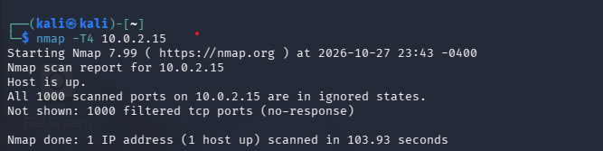

2. Insane Speed Scan
Command
nmap -T5 10.0.2.15
Explanation:
- -T5 specifies the Insane timing template, which attempts to scan as quickly as possible.
- 10.0.2.15 is the IP address of your Kali Linux machine.
This timing option is more aggressive and may miss results under slow or unreliable network conditions.
Screenshot:
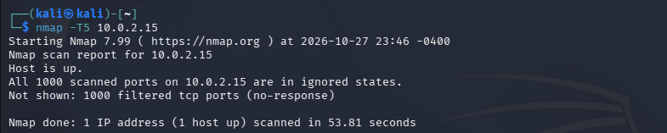

Result
Thus, the Nmap aggressive timing (-T4) and insane timing (-T5) scans were executed in Kali Linux, and their outputs were displayed and observed.

